**Q1.** (Code File: q1.py)

**1.1**

Call Option Price: 2.9380121169138036

Put Option Price: 2.6886360765479225

**1.2**

Call Option Price: 0.3870694028577839

Put Option Price: 10.08781815441872

**1.3**

Call Option Price: 4.216659345054804

Put Option Price: 3.7191510325132064

**1.4**

Call Option Price: 4.338822781168002

Put Option Price: 4.089446740802121

**1.5**

Call Option Price: 3.060327056727921

Put Option Price: 2.5628187441863233

Comment on how increase in each parameter affects call and put values (look at appendix for graphs) (Code File: q1_comments.py):

|  |  |  |  |  |
| --- | --- | --- | --- | --- |
| Option | Strike Price 🡩 | Maturity 🡩 | Volatility 🡩 | Risk Free Rate 🡩 |
| Call | 🡫 | 🡩 | 🡩 | 🡩 |
| Put | 🡩 | 🡩 | 🡩 | 🡫 |

**Q2.**

**2.1**

**2.2** (Code file: q2.py)

Sample Size = 200

Mean_X: 0.06 Mean_Y: 0.06 Var_X: 0.0 Var_Y: 0.0 Mean_Z: 0.08 Var Z: 0.0

The value of the correlation coefficient p(X,Z)= 0.48

This value is slightly different from the theoretical value of 0.5. This is because the variables arent a perfect standard normal owing to the small sample size, X has a mean of 0.06 and a variance of 0.0, while Y has a mean of 0.06 and a variance of 0.0

If the number of samples are increased, the distribution will be almost approximate to a standard normal and yield a correlation equal to the theoretical value of 0.5 (as seen below with a much larger sample size)

Sample Size = 20000000

Mean_X: 0.0 Mean_Y: 0.0 Var_X: 0.0 Var_Y: 0.0 Mean_Z: 0.0 Var Z: 0.0

The value of the correlation coefficient p(X,Z)= 0.5

**Q3.**

**3.1** Calculating Implied Volatility (Code file: q3-1.py):

Following algorithm has been used

def get_implied_volatility(S,K,T,t,r,q,Ctrue,optiontype):

    # Use Newton's method to calculate Implied Volatility

    #starting value

    sigmahat = sqrt(2*abs( (log(S/K) + (r-q)*(T-t))/(T-t) ) )

    tol = 1e-8; # Tolerance

    nmax = 1000  # Number of Iterations

    sigmadiff=1

    n=1

    sigma=sigmahat

    bs=BlackScholes() # Initialize an Option object

    while (sigmadiff>=tol and nmax>n):

        if optiontype=='call':

            C=bs.euro_dividend_and_borrowing_cost(S,K,T,t,sigma,r,q,'call')

        else:

            C=bs.euro_dividend_and_borrowing_cost(S,K,T,t,sigma,r,q,'put')

        d1=bs.d1_d2(S,K,T,t,sigma,r,q)[0]

        Cvega=bs.vega(S,K,T,t,r,sigma,q)

        increment= (C-Ctrue)/Cvega

        sigma=sigma-increment

        n=n+1

        sigmadiff=abs(increment)

    return sigma

**3.2** (Code file: 3-2.py)

**3.2.1** The bid and ask implied volatilities have been calculated and the results can be found in 31.csv, 32, and 33 csv files as has been instructed.

**

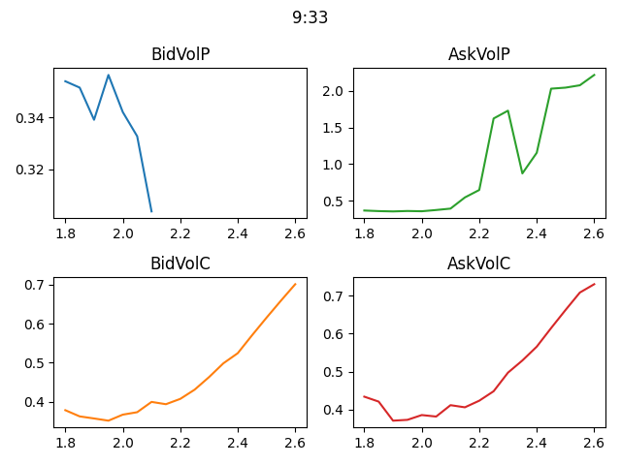

**3.3** Arbitrage Opportunities (Code file: q3-arbitrage.py, Data and Results file: arbitrage_opportunities.csv)

The data was investigated for the following arbitrage opportunities:

* Put- Call Parity
* Call Option Bound
* Put Option Bound
* Call Option Vertical Spread
* Call Option Non-Negative Butterfly Spread

The results of all arbitrage opportunities can be found in the file arbitrage_opportunities.csv

Here is a summary:

* A total of 521 arbitrage opportunities have been found in the data
* All the opportunities exist due to violation of Put-Call parity
* 499 of these can be exploited by creating the following portfolio: Short-sell call, Short-sell bond, Buy Put, Buy Underlying
* 22 of these can be exploited by creating the following portfolio: Short-sell put, Short-sell underlying, Buy Call, Buy Risk Free Bond
* The number of arbitrage opportunities including transaction cost of 3.3RMB per option unit: 425
* The total arbitrage profit that can be made after including transaction cost: 4020.73RMB
* The total arbitrage profit for cases without transaction cost: 140.17RMB

Appendix: Plots for Option Price vs Parameters

